Enable port 1880

**sudo ufw allow 1880**

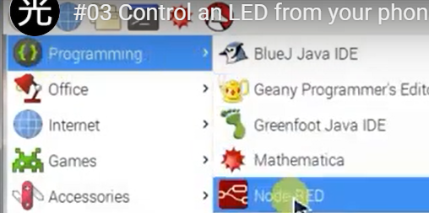

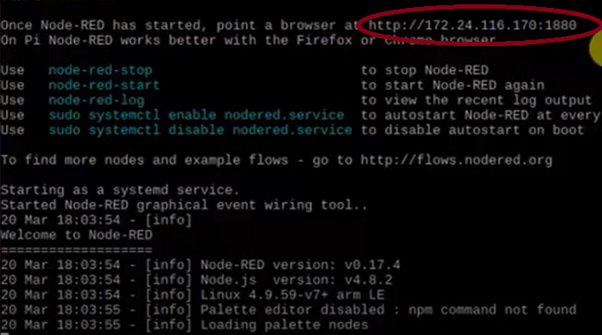

[**http://172.24.116.170:1880/ui**](http://172.24.116.170:1880/ui)

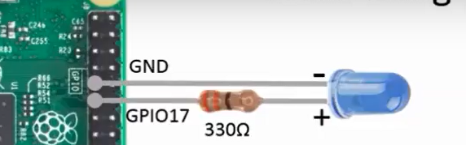

**Longer is ( + )**



[**https://www.youtube.com/watch?v=RXvpYHK2Q-I**](https://www.youtube.com/watch?v=RXvpYHK2Q-I)

**Encender y apagar LED**